**PROJECT 2**

Janhvi Mishra

**Deploy a Static Website on AWS**

**[PROJECT 2]**

# **INTRODUCTION**

**STATIC WEBSITE** - A static website is delivered to the user exactly as stored, in contrast to dynamic web pages which are generated by a web application. Static websites are best for sites with few authors and relatively infrequent content changes. Common use cases for static websites are personal and simple marketing websites. Static websites simply deliver the HTML, JavaScript, images, video and other files as stored to your website visitors, and contain no application code.

**WEBSITE HOSTING** - The infrastructure environment used to enable end users to request, receive, and interact with your website is commonly referred to as “hosting.” With AWS, you build and maintain your own hosting environment. Other options include managed hosting and Software-as-a-Service (SaaS). With managed hosting, a business will create and maintain the hosting environment for your site. If you’re interested in managed hosting, check out Acquia or our other certified partners. SaaS options bundle software (typically for creating and maintaining your site) with the infrastructure that is required to host your website.

# **OVERVIEW**

* Step 1: Creating my S3 bucket.
* Step 2: Enabling static website hosting.
* Step 3: Securing my S3 bucket through IAM policies.
* Step 4: Uploading web files to my S3 bucket.
* Step 5: Testing my website endpoint.

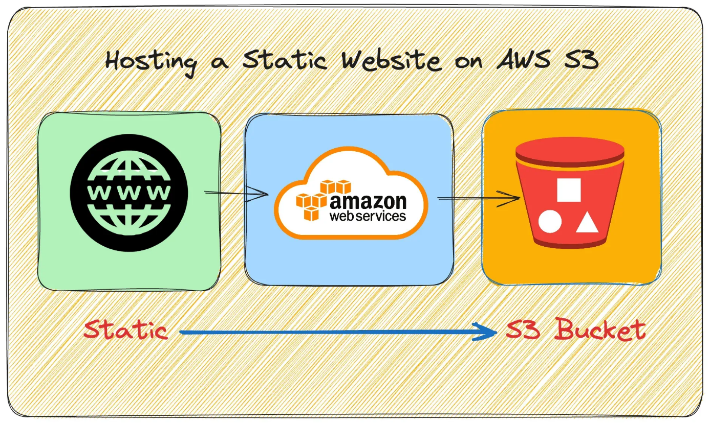

# **STEPS**

**Step 1: Creating my S3 bucket**

* Sign in to the AWS Management Console.
* Open the Amazon S3 console.
* Click on Create bucket.
* Enter the name of the bucket as **staticwebsitebucket15**.
* Choose a Region i.e. Asia Pacific (Mumbai) ap-south-1.
* Under “Block Public Access settings for this bucket” section, uncheck the “Block all public access” checkbox and accept the acknowledgement.
* Select “Disable” for Bucket Versioning.
* Under “Default encryption” section, click on disable for Server-side encryption.
* Click on “Create bucket”.

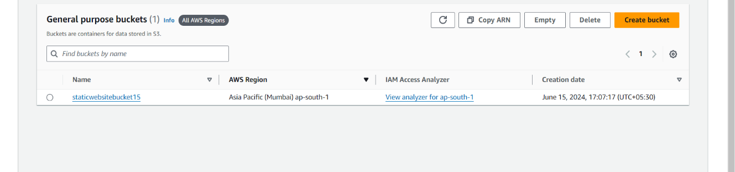

**Step 2: Enabling static website hosting**

* In the Buckets list, choose the name of the bucket that you want to enable static website hosting for (**staticwebsitebucket15)**
* Click on the “Properties” tab.
* Scroll down to the “Static website hosting” section and click on its Edit button.
* Under Static website hosting, choose Enable. Also, select Host a static website for the Hosting type. In Index document, enter the file name of the index document, typically index.html.
* Click on “Save Changes”. You should see the following next.

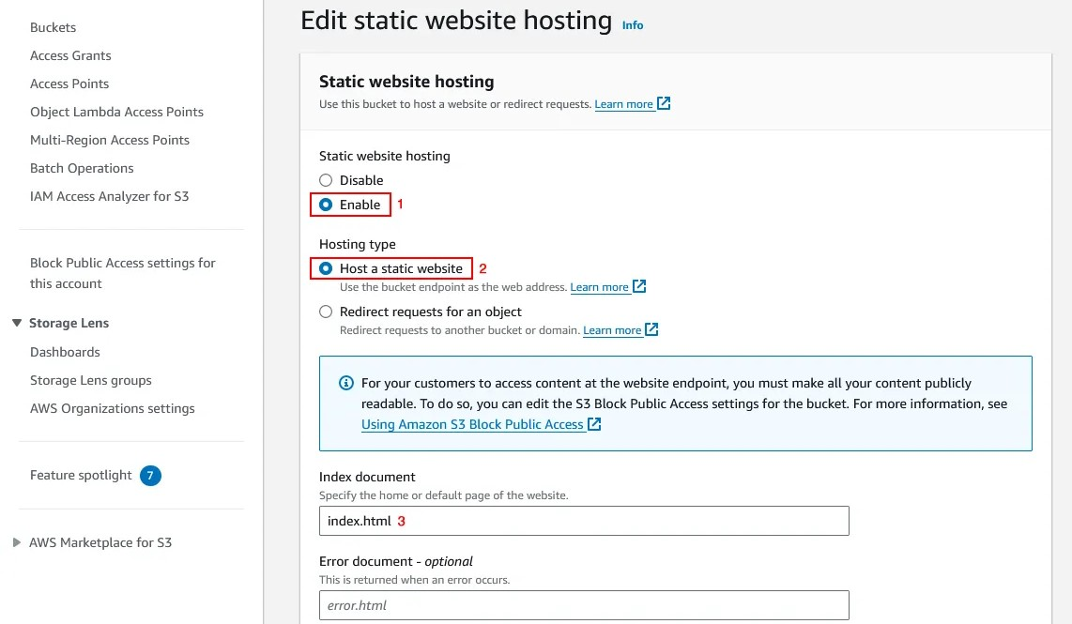

**Step 3: Securing my S3 bucket through IAM policies**

* Under Buckets, click on the name of your website bucket.
* Click on the “Permissions” tab.
* Under Bucket Policy, choose Edit.
* To grant public read access for your website, copy paste a code in the Bucket policy editor. Make sure to replace bucket-name with the name of your bucket.

{  
"Version": "2012-10-17",  
"Statement": [  
{  
"Sid": "PublicReadGetObject",  
"Effect": "Allow",  
"Principal": "*",  
"Action": [  
"s3:GetObject"  
],  
"Resource": [  
"arn:aws:s3:::Bucket-Name/*"  
]  
}  
]  
}

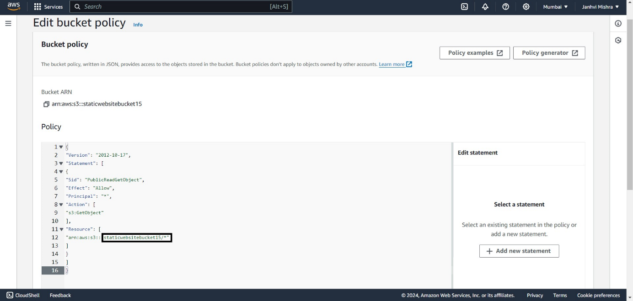

* Scroll down and click on “Save changes”.

**Step 4: Uploading web files to my S3 bucket**

* Under Buckets, click on the name of your website bucket.
* On the Objects tab, you can see that the bucket is currently empty, click on the Upload button.
* This should take you to the Upload page. Click Add files to add the website files and use Add folder to add the website folders.
* Now after uploading the file you will see your file in the object section of your bucket.

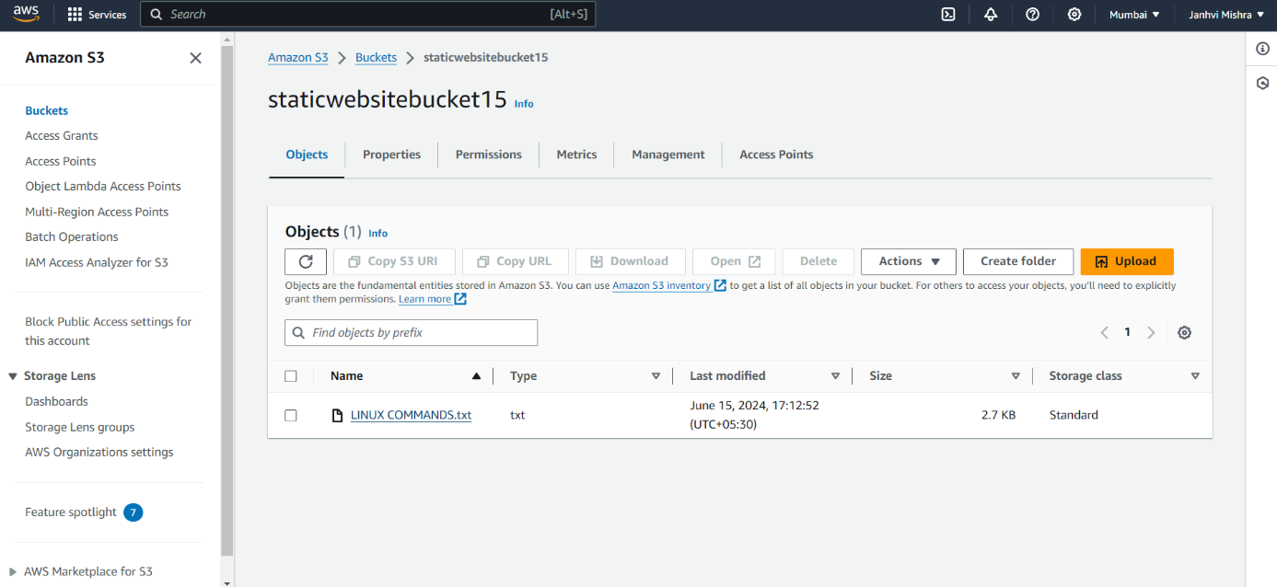

**Step 5: Testing my website endpoint**

* Under Buckets, click on the name of your website bucket.
* Click on the “Properties” tab.
* Scroll down to the “Static website hosting” section and click on your endpoint URL.
* Now copy the object URL for running it in your browser.

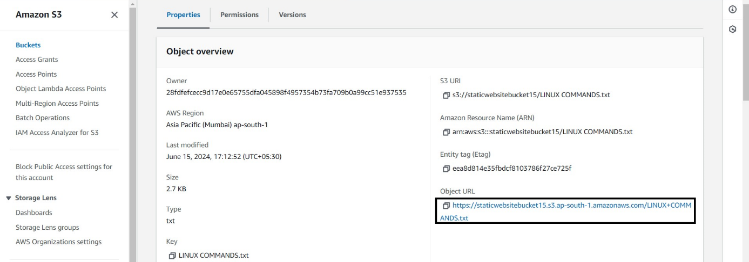

* As you run your URL in the browser you will see your content of your file which you have uploaded in your bucket.

